- (10 Points) Consider the electrical network shown in Fig. 1.
(1) Find its state space model when the state are chosen to be 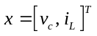. (5 points)
(2) If R=1, L=1, C=1, is the system controllable? Is it observable? (5 points)
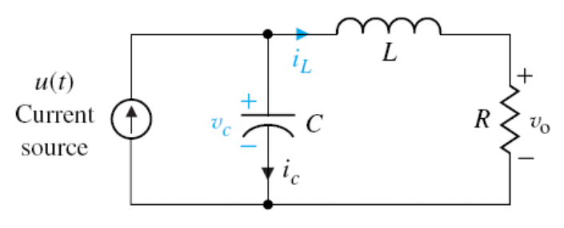
Fig. 1 RLC network

- (10 Points) Consider the linear algebraic equation
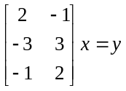
Does a solution x exist and unique in the equation when 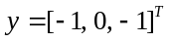? Does a solution exist if 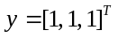? Please give detailed explanation.

- (10 Points) For matrix 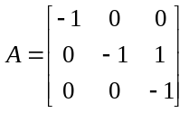, compute 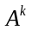 and 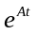.

- (20 Points) Consider the CT-LTI system Suppose there exists a positive constant and positive definite matrices P, Q for which the following Lyapunov equation
holds. Prove that all eigenvalues of have real parts less than .

- (20 Points) Consider the linear system
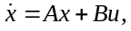
where 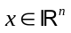 is the state and 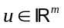is the input. Show that this system is controllable if and only if the matrix
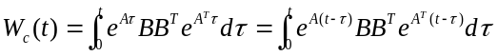
is positive definite for any 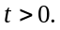
- (10 points) Consider the LTI system
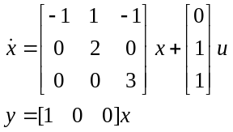
Try to design a state feedback control law to shift the eigenvalues to -1, -2, -3 by transforming the above system to controllable form.
- (20 Points) Use Dynamic Programming or Completing the square to find optimal control sequence u₀, u₁, ..., u_{N−1} to minimize following J_{N}(z, u)
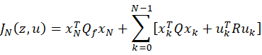
subject to linear dynamics constraints:
x_{k+1} = Ax_{k} + Bu_{k}, x₀ = z
Hint: The recursive Riccati sequence is
